1.24 Goods Manage System UI and Database

After completing the first part of the development (the points monitoring system), I began the second part: the goods manage system. The overall approach was the same as the previous system. The UI still used a three-layer structure of data, structure, and rendering, while the database was still implemented using spreadsheets and API interfaces.
For this system, the MVP standard is:
- Users can add new goods: add name, quantity, price, image link, and description of it.
- Users can modify these fields of the added products.
- Users can use the search box to quickly find a product.
- All the data is connected to a single database, and all operations modify the contents of this database in real time.
I used ChatGPT as a tool to quickly convert my ideas into HTML code. I will introduce the overall structure later (the underlying concept is not significantly different from the previous system).
Basic structure of web app
This web app can be understood as a three-layer system:
Data layer:
In this system, there is only one data structure (items) for storing product information. It stores these fields:
Fields | Types | Example | Meaning
item_id | string | “I_20260123_alf2” | Unique good identifier
name | string | “Pencil” | Name
price | int | 20 | Price
qty | int | 12 | Remaining quantity
img_url | string | “https://images.unsplash.com/photo-1524995997946-a1c2e315a42f?auto=format&fit=crop&w=1200&q=60” | Image URL
note | string | “HB” | description
updated_at | string | “2026-01-28T00:59:03.256Z” | Last update time

This array stores information about all the goods. The fetch() method will be used later to send a request to the spreadsheet to populate this array.
Structure layer:
The UI structure of the entire web app can be divided into two parts: upper part and lower part (As shown in Fig. R1).

Upper Part | Lower Part
The structure is fixed and does not require rendering. Static components:  - Title and subtitle  - Search box  - Filter (based on name, price and quantity)  - Quick statistics  - Rules | Consists of cards representing goods. These cards are rendered, and their structure is fixed. Static components of each card:  - Information (name, image, price, quantity, id, and description)  - Editing button  - Buttons for quickly increasing or decreasing the quantity

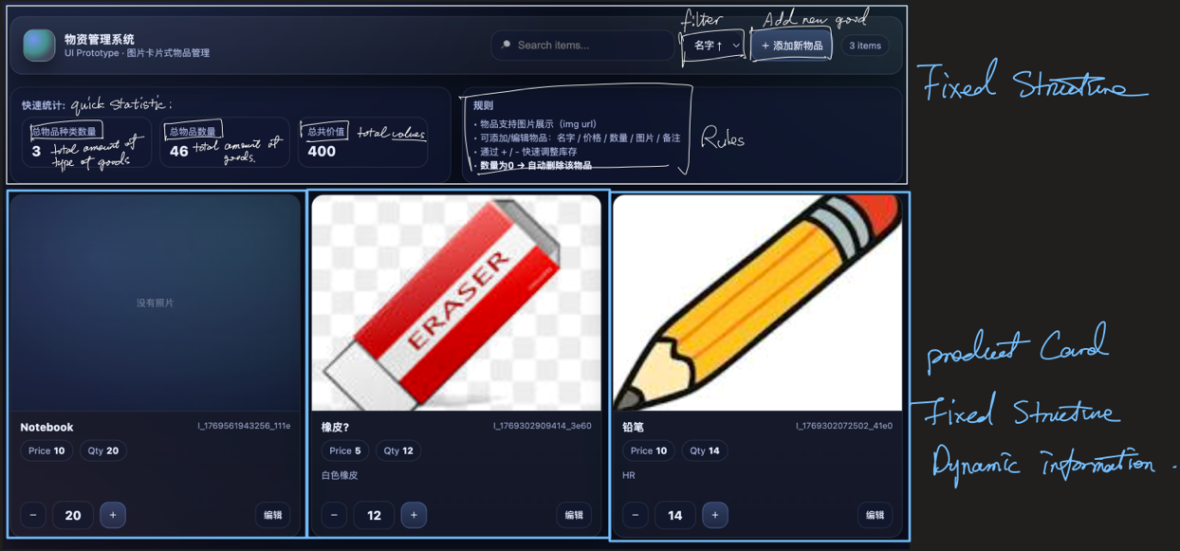
Figure R1. The Structure of UI Skeleton
The UI structure of the entire web app can be divided into two parts: upper part and lower part (As shown in Fig. R1).

In addition to the overall structure, this page also includes two forms for creating/modifying good’s information, which can be expanded using the Add New Item and Edit buttons (As shown in Fig. R2 and Fig. R3).

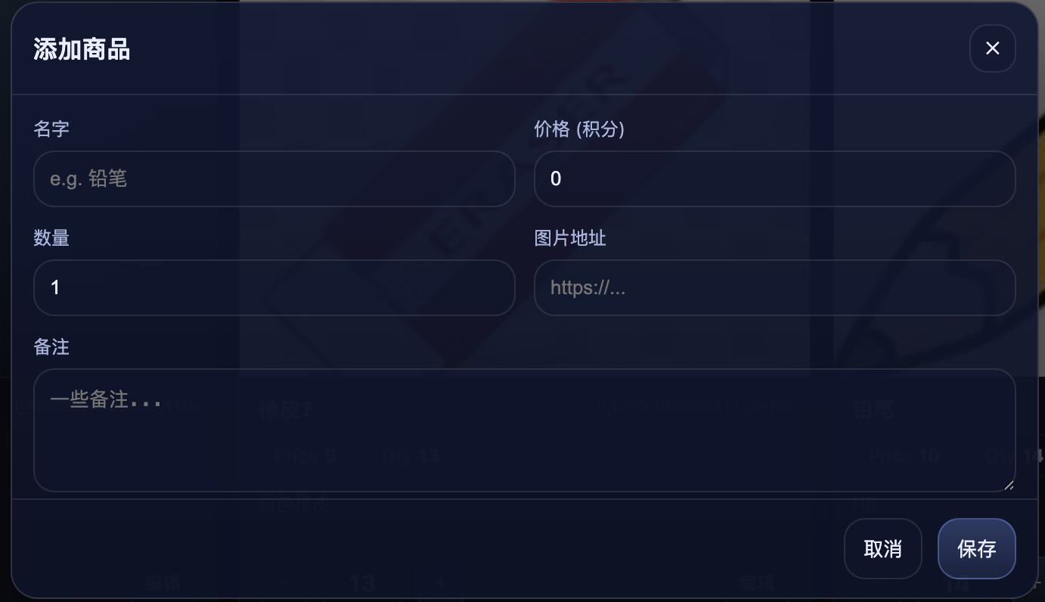
Figure R2. Form of adding a new item
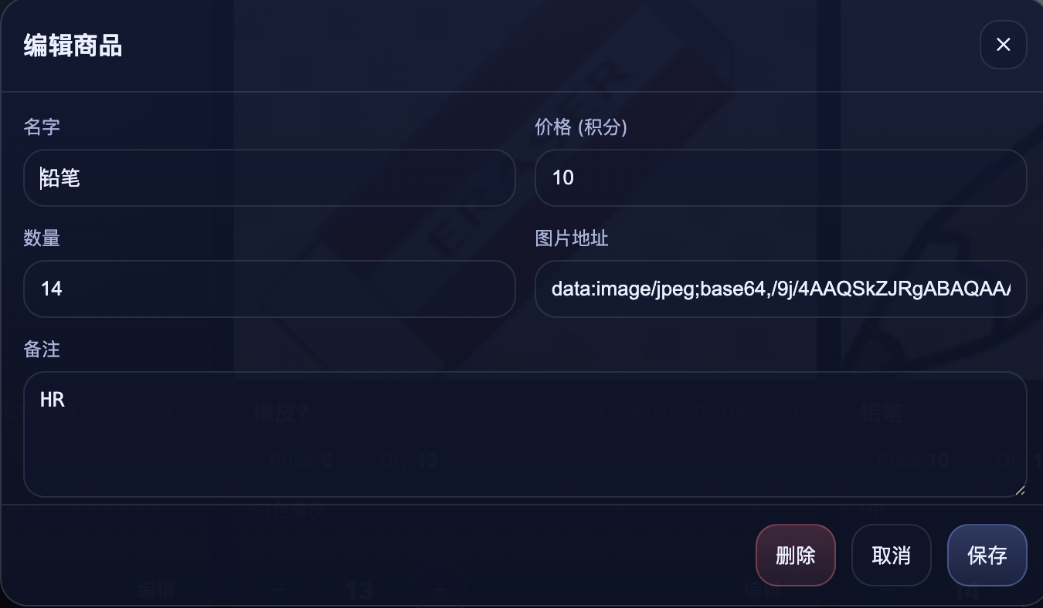
Figure R3. Form of editing information of a good

Rendering layer:
This layer uses the same pipeline approach as the rendering layer of the points monitoring system. This time, there’s only one function for this layer.
User action $→$ state/data update $→$ render() $→$ UI refresh
The entire render() method consists of three steps:
- filtering and determining the data to be rendered (filter by search key words and filter fields)
- embedding the data into the card structure
- binding the button (increase quantity button, decrease quantity button, edit button)

Data Storage
This system still uses Google’s spreadsheet as its data base. Use fetch() method with different action to interact with the data base trough Web App API.
Downloading Part
At local program’s side, loadItems() function uses fetch() with action=items to send a request to spreadsheet. At another side, spreadsheet receive the request in doGet() function and send back all the data in the spreadsheet.
Uploading Part
At local program’s side, postAction() is responsible for this part. It uses three different actions (updateItem, deleteItem, addItem) to distinguish different operations. It uses fetch() to send a request with specific data to data base.
At another side, data base will distribute requests based on action.
For action = addItem, data base will break down the data sent in the request and assemble it into a piece of good data, then push it into the spreadsheet.
For action = deleteItem, data base will find that good based on item_id and delete that row.
For action = updateItem, data base will find the good based on item_id first and extract data from the request and overwrite the original data with the new data. If the quantity of new data is 0, then delete this item.

